Data Flow Diagram
Date | 30 September 2026
Team ID | SWTID-2026-3934/6ab4dd426603573ccfb5912f
Project Name | AI BlogNest API
Maximum Marks | 2 Marks
Data Flow Diagram
The Data Flow Diagram below shows how data moves through the AI BlogNest API: between the User, the three processes (Authentication, Blog Management and the AI Content Service), the two MongoDB data stores, and the external Google Gemini API.
DFD Symbol Legend
Symbol | Name | Description
Oval / Rounded shape | External Entity | A person, organization, or system outside the project that sends or receives data (e.g., Customer, Payment Gateway).
Rectangle with numbered header | Process | An activity that transforms incoming data into outgoing data (e.g., Validate Request, Process Order).
Rectangle (solid fill, no number) | Data Store | A place where data is held for later use (e.g., Customer Database, Inventory).
Labeled arrow | Data Flow | The movement of data between entities, processes, and data stores, labeled with what data is being passed.
AI BlogNest API: Data Flow Diagram
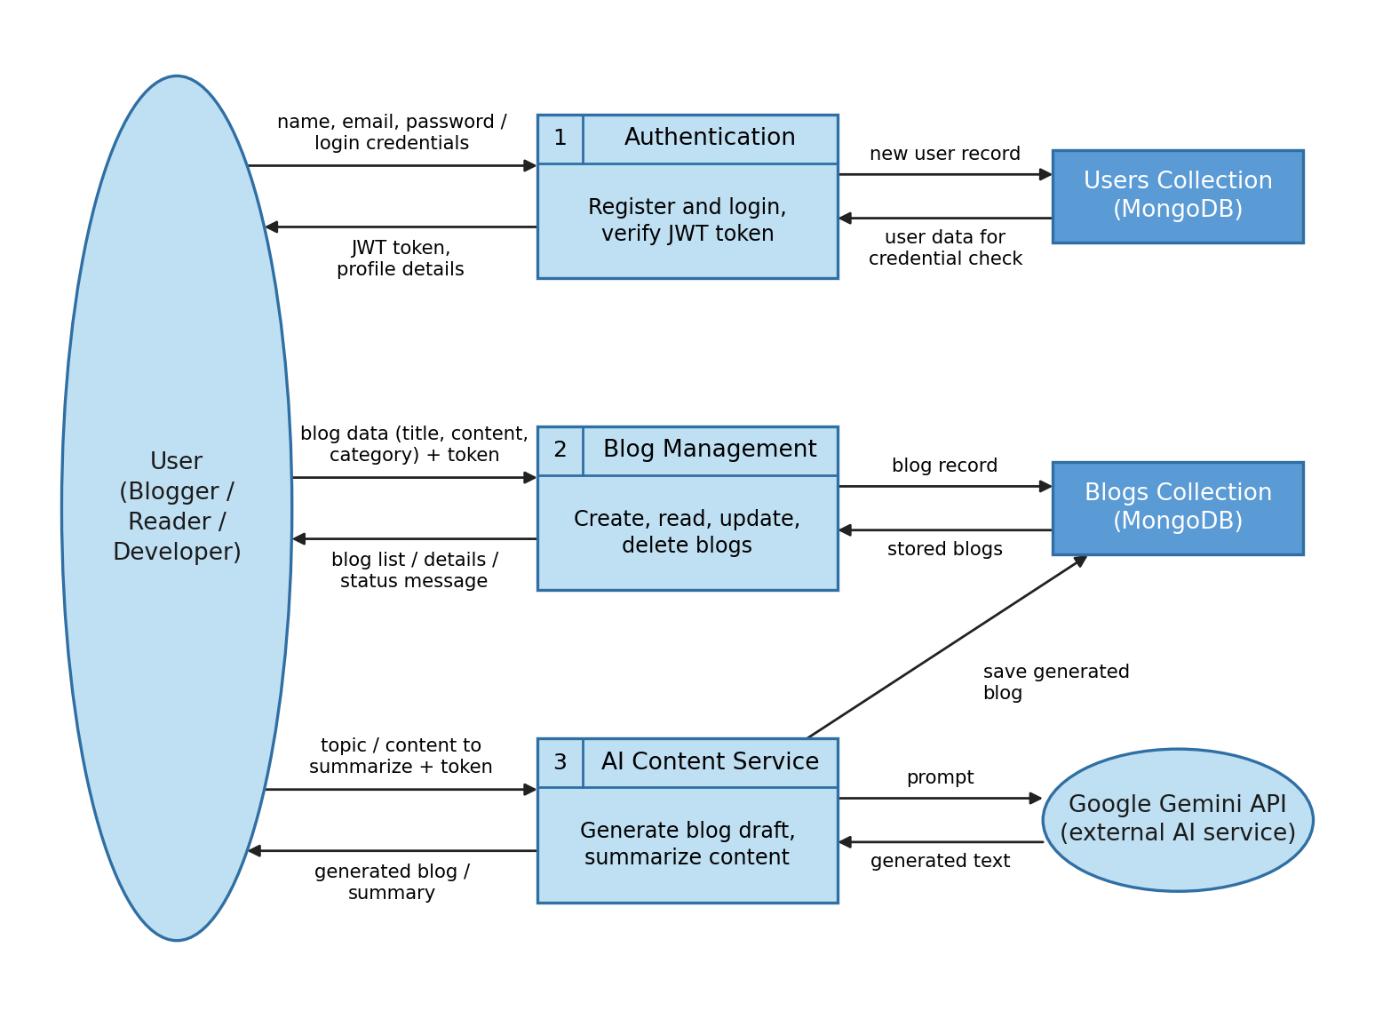
Data Flow Description
Each numbered row below is one labeled arrow in the diagram. Private actions (creating, editing or deleting blogs and generating a blog with AI) need the JWT token issued by Process 1.
No. | From | To | Data Passed
1 | User | Process 1: Authentication | Name, email, password (register) or email and password (login)
2 | Process 1: Authentication | User | JWT token (7-day expiry), profile details or error message
3 | Process 1: Authentication | Users Collection | New user record with bcrypt-hashed password
4 | Users Collection | Process 1: Authentication | Stored user data for credential check
5 | User | Process 2: Blog Management | Blog data (title, content, category) and JWT token
6 | Process 2: Blog Management | User | Blog list, blog details or status message
7 | Process 2: Blog Management | Blogs Collection | Blog record to create, update or delete
8 | Blogs Collection | Process 2: Blog Management | Stored blogs (newest first, with author details)
9 | User | Process 3: AI Content Service | Topic (and optional category) or content to summarize, with JWT token for blog generation
10 | Process 3: AI Content Service | Google Gemini API | Prompt built from the topic or content
11 | Google Gemini API | Process 3: AI Content Service | Generated text
12 | Process 3: AI Content Service | Blogs Collection | Generated blog saved under the logged-in author
13 | Process 3: AI Content Service | User | Generated blog or short summary

